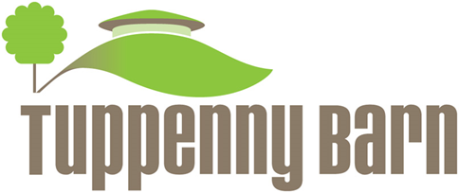

Cheese and herb Muffins
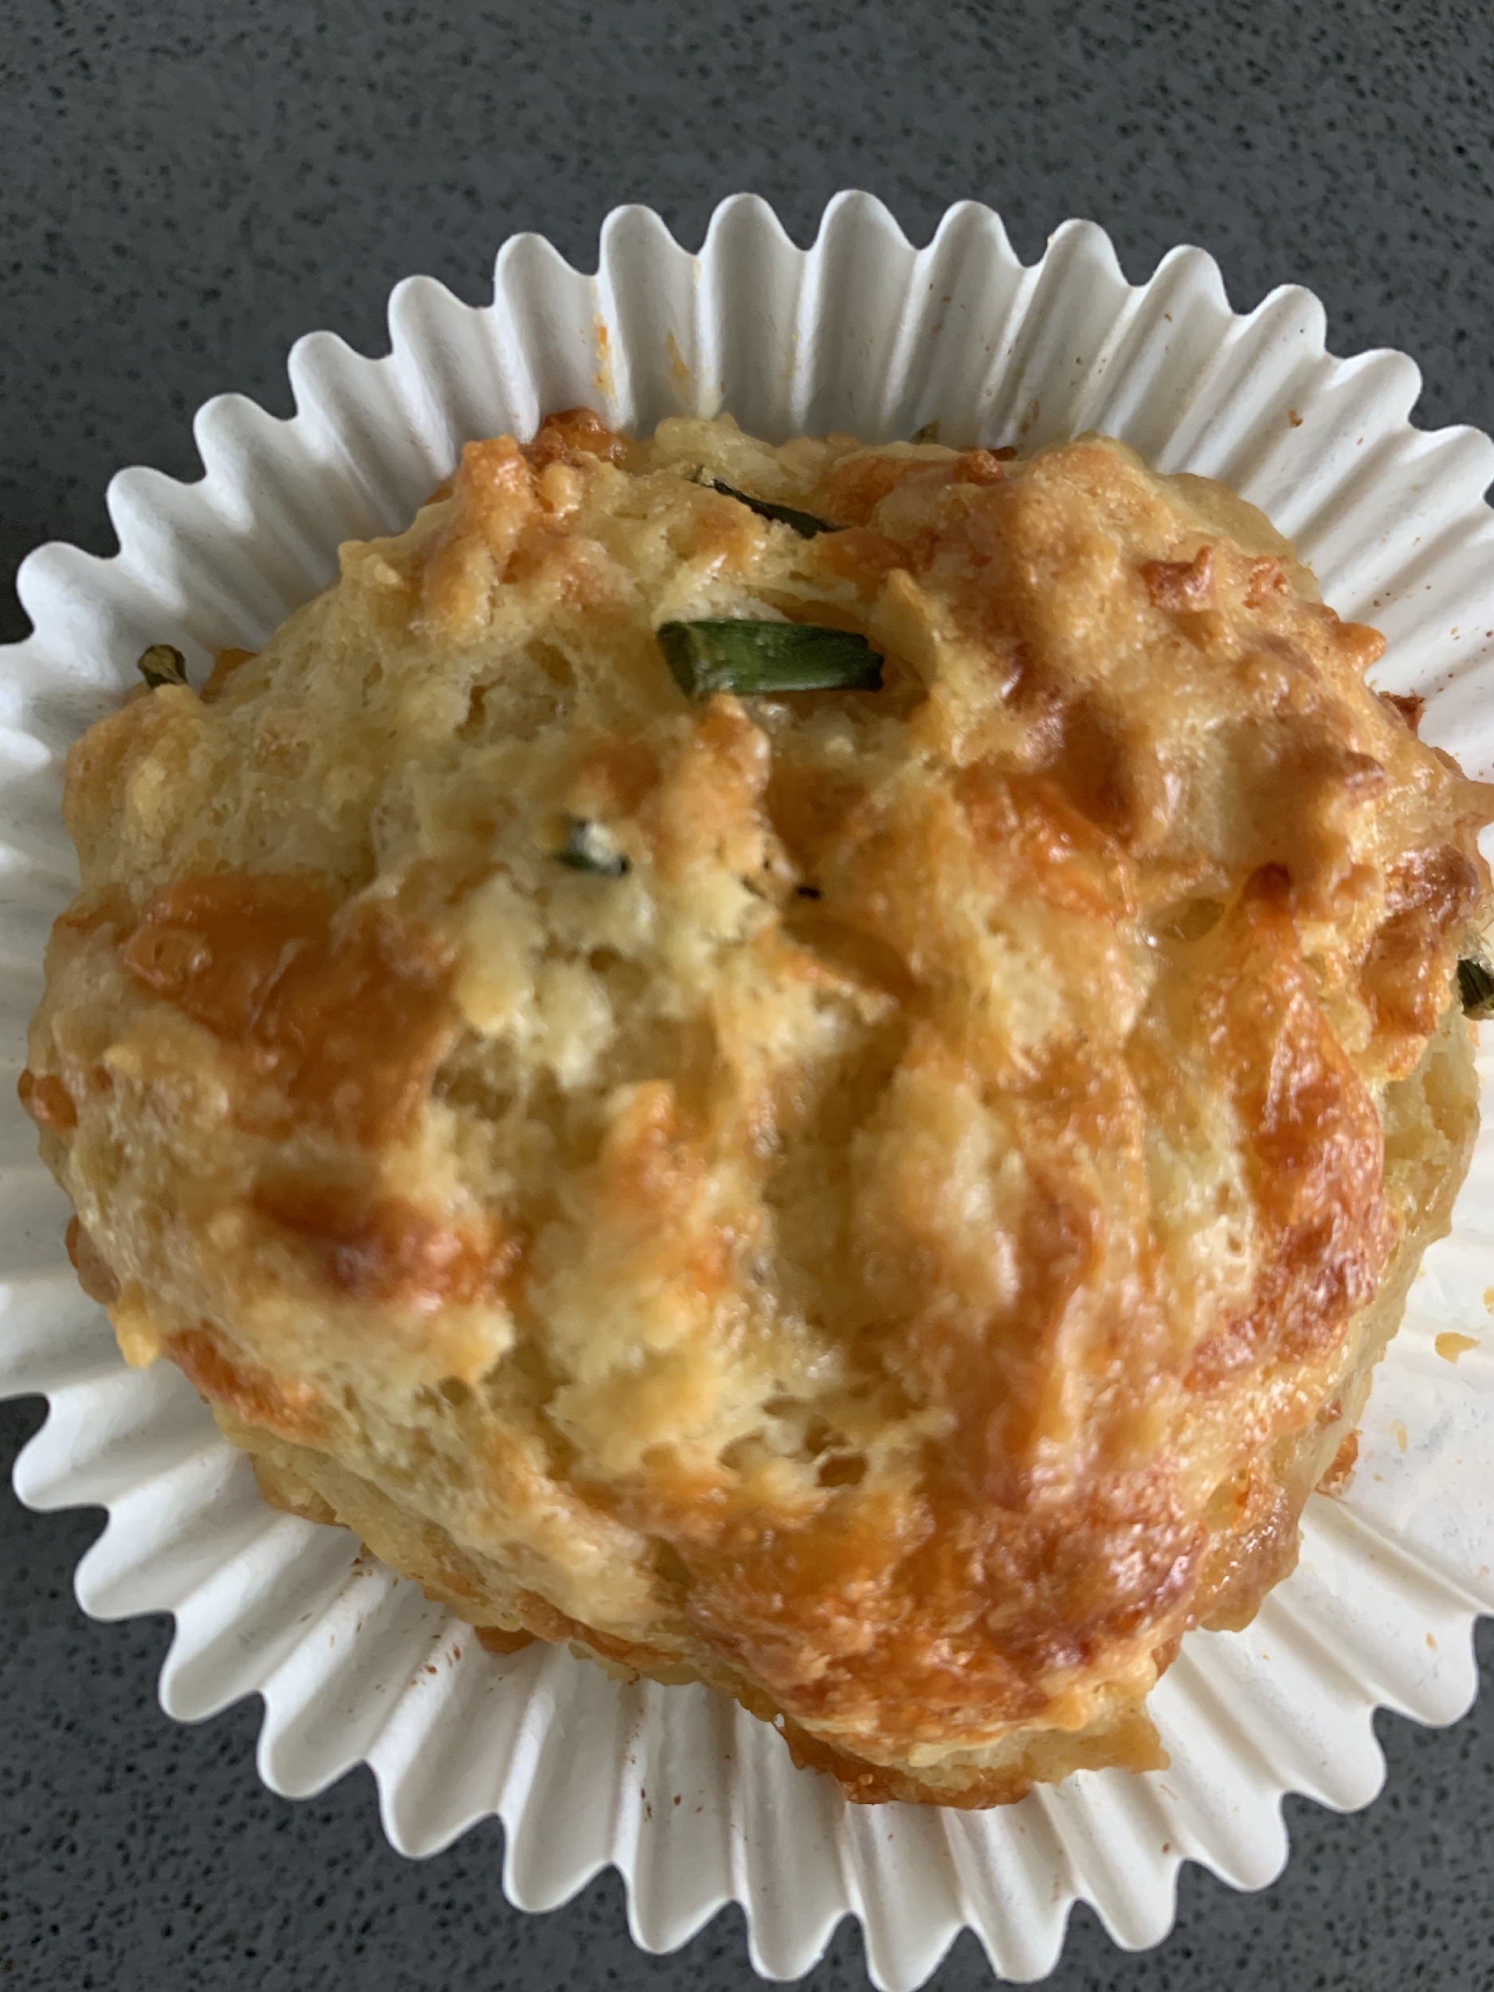
Makes 8

Ingredients
1 egg
75ml milk
60g melted butter
75g cheddar cheese, grated
1 tbsp chopped herbs eg chives, thyme or sage
125g Self Raising flour
Salt and pepper
8 muffin cases in a muffin tin

- Mix together the egg, milk and melted butter in a bowl or jug.
- In a separate bowl mix together the flour, herbs, grated cheese and salt and pepper.
- Add the wet ingredients to the dry ingredients and mix, leave this lumpy.
- Spoon into 8 muffin cases and bake for 15 minutes at 180.

