Keyworker
Louise Cox
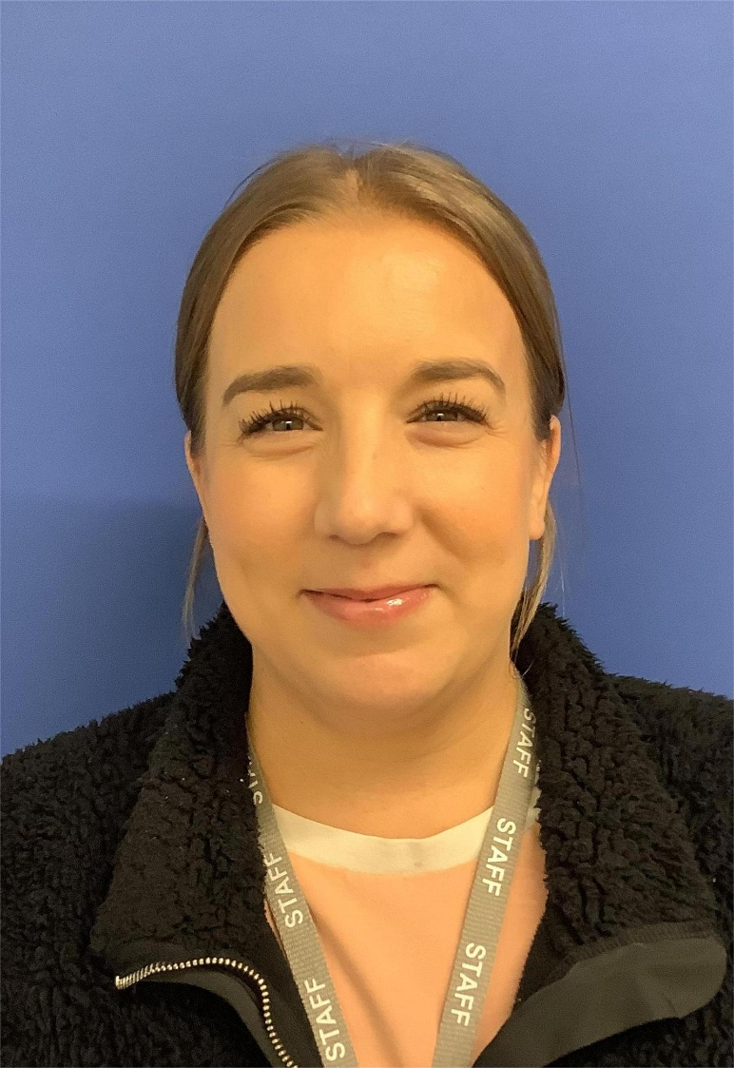

Qualification: Diploma for Early Years Educator Level 3
Food hygiene: Level 2 Food hygiene and safety for catering

