Westover Primary School
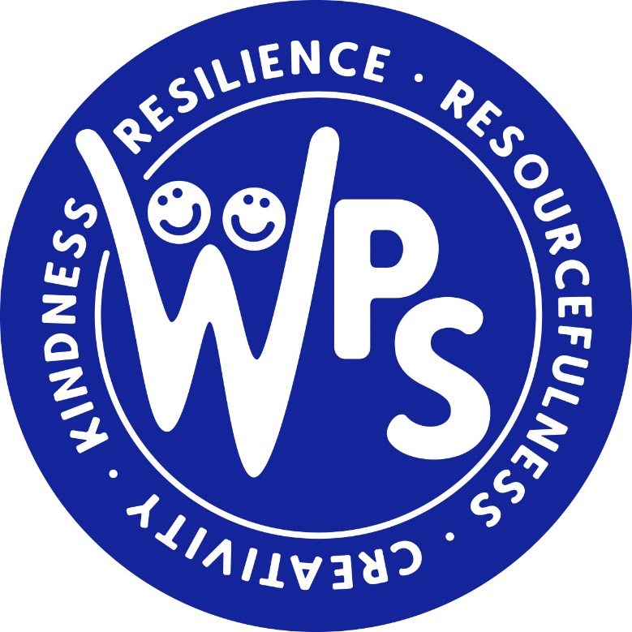

RE Policy

WESTOVER PRIMARY SCHOOL
RE POLICY
At Westover Primary School our aim to develop happy, confident and curious learners who are keen to explore the world around them; to develop their understanding of a range of faiths, views and beliefs both in and beyond our local area. Pupils at Westover Primary School explore religious beliefs – appreciating the similarities and differences between Christianity and other faiths. Our Religious Education curriculum provides all children with a strong foundation built on knowledge. This enables them to develop their critical thinking skills, develop respectful and open-minded attitudes.
Religious Education plays a key role in the development of children’s values and fosters in a reflective approach to life in order to develop their spiritual, moral, social and cultural understanding. This policy will establish an agreed philosophy for Religious Education which supports the vision and aims of the school. The policy will also clarify any legal requirements for Religious Education for all staff, parents and governors.

Aims:
At Westover Primary School we aim to
- Develop an enquiring and questioning mind.
- Develop an interest in religious and spiritual issues.
- Promote reflection, empathy, investigation, interpretation and evaluation of religious cultures.
- Provide a clear statement of intention that reflects the ethos and aims of the school.
- To support a consistent approach to Religious Education in the school.
- To promote knowledge, skills concepts and attitudes appropriate to Religious Education.
- To promote attitudes of curiosity, open mindedness, self-awareness, respect, wonder and appreciation in order to acquire a more holistic understanding of the religious and spiritual dimension of human life.
- To provide an overview of religious education in line with the requirements of ‘Living Difference lV.’

Legal Requirement:
In accordance with the Education Act 1996, RE should be taught to all pupils, except those withdrawn in line with their parents’ wishes. Teachers’ rights are safeguarded, should they wish to withdraw from the teaching of RE. The school will use the syllabus ‘Living Difference IV’ (Revised November 21) as a basis for the RE Curriculum.

Procedures
Roles and Responsibilities

The Headteacher is responsible for ensuring that the requirements of the 1996 Education Act and the agreed syllabus are adhered to. The RE leader is responsible for developing the policy and scheme of work for Religious Education. Through long and medium plans the RE leader should also ensure that there is clear continuity and progression across the key stages. The RE leader will monitor standards of attainment across the school.

Parent Partnership
In accordance with the Education Reform Act 1988, parents have the right to withdraw their children from parts of or all religious education lessons, and they are not obliged to state their reasons. Parents would be encouraged to meet with a Senior Leader to discuss or email into parents@westoverprimary.co.uk

Implementation
Religious Education is taught in accordance with the agreed syllabus ‘Living Difference IV’. It is not the intention of the school to promote any one religious viewpoint through Religious Education.

The Foundation Stage
Children in Year R gain an understanding of different religions and concepts through the ‘Understanding the World’ area of learning aligned to ‘People Culture and Communities’ and ‘Building Relationships’ strands of development.

Key Stage 1
The curriculum is planned to deliver RE through a combination of methods:
- Religious Education is taught through lessons following the enquiry cycle;
- The opportunity is also taken to deliver identified areas of Religious Education through assemblies. The work is carefully planned and followed up in class when appropriate;
- Separately identified RE is found at different times of the year covering Christmas, Easter, Harvest, Advent, Shrove Tuesday, Diwali, Eid etc. We will also reflect the Faiths within our community and widen knowledge by looking beyond Portsmouth
- The teaching and learning of RE will be enhanced through the use of visits and visitors. The school has established good links with City Life Church.

Representatives from the church may be invited into school to contribute towards some aspects of the Christianity units of work.
A wide range of teaching and learning strategies will be used to deliver Religious Education effectively
- Visits to places of worship.
- Visits from members of different faith communities.
- Exploring a range of religious artefacts.
- Stories from a range of religions and cultures.
- Reflection on religious symbols, sounds and the use of silence.
- Creative Arts including Role play, art, dance and drama to enhance learning opportunities.

Wherever possible we encourage first hand experiences as a stimulus for learning. We encourage the children to ask questions and form opinions through discussions.

Inclusion and Equal Opportunities
As according to the Agreed Syllabus pupils with Special Educational Needs will be taught RE. In line with the school’s policy the needs of all pupils will be catered for through effective teaching and adaptations.
In addition, it is important in religious education to ensure the work being covered is appropriate to pupils who come from any religious background or none.

Spiritual, Moral, Social and Cultural Development
RE provides an opportunity for children to develop spiritually, morally, socially and culturally. In RE, as well as Collective Worship and PSHE, children are invited to communicate, apply, enquire and reflect. They have opportunity to develop their personal responses, consider other people’s views and feelings and develop a sense of identity and belonging.

Assessment and Reporting
In the Early Years Foundation Stage Each child’s level of development must be assessed against the early learning goals in the EYFS Profile. Teachers must indicate whether children are meeting expected levels of development, or not yet reaching expected levels (‘emerging’). RE forms part of the Early Learning Goal ‘Understanding the World’.
In Key Stage 1 assessment opportunities will be used at the end of each year against the end of Year ‘Age Related Expectations’ (ARE), as in Living Difference’s National Curriculum Levels.
The Subject Leader will track provision and progress through monitoring planning, work sampling, discussions with pupils and analysing end of year assessment data.
Parents will be informed of their children’s progress through their child’s annual report.
Children’s achievements in RE are celebrated in whole school and class displays.

Evaluation

- This policy will be promoted and implemented throughout the school
- This Policy will be reviewed every 2 years.

