

Acceptable Use of IT Policy – Pupils KS1-2

Reviewed on |  | Sept 2026 |  | Review frequency |  | Annually
Next review due |  | Aug 2027 |  | Template Yes / No |  | Yes
Owner |  | Director of IT |  | Approved by |  | Executive

History of Policy Changes
Date | Page | Change | Origin of Change

Contents
1. History of Policy Changes 2
2. Contents 2
3. Introduction 3
4. My Safe Technology Promises 3
5. What the school will do 4
6. My Agreement 4
7. Information for Parents and Carers 4

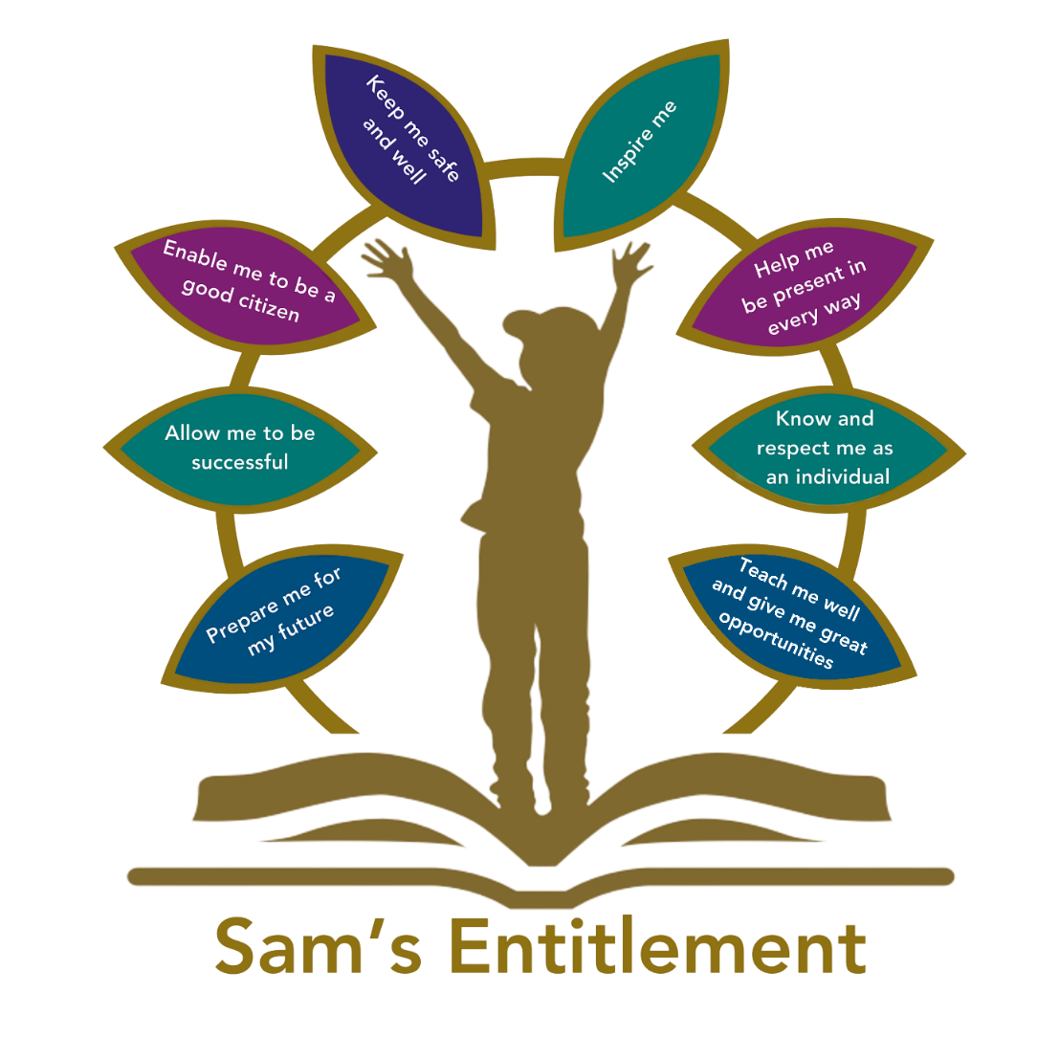

Introduction
Technology helps us learn, create and communicate. These rules help to keep you, other people and the school’s devices and information safe.

Remember
If anything online worries, confuses or upsets you, stop and tell a trusted adult. You will not be in trouble for asking for help.

My Safe Technology Promises
✓ I will use technology for learning | I will use school devices, websites, apps and accounts in the way my teacher asks.
✓ I will be kind | I will use friendly and respectful words. I will not send or share anything that could hurt, frighten or embarrass someone.
✓ I will keep personal information private | I will not share my full name, address, phone number, password, location or photographs unless a trusted adult says it is safe.
✓ I will keep passwords safe | I will use only my own account. I will not share my password or try to use another person’s account.
✓ I will ask before taking or sharing pictures | I will only take, record or share photographs, videos or sound when a teacher gives permission.
✓ I will stay on approved websites and apps | I will not download, install or buy anything, or click adverts and pop-ups, without permission.
✓ I will tell an adult if something goes wrong | If I see something unsafe, unkind or unsuitable, I will stop, leave it on the screen if safe to do so, and tell a trusted adult straight away.
✓ I will look after equipment | I will carry devices carefully, keep food and drink away, and report damage or problems.
✓ I will not try to get around safety controls | I will not change settings or try to bypass the school’s filtering, monitoring or security.
✓ I will use AI only when my teacher allows it | I will ask before using an AI tool. I will not tell it private information, and I will check its answers with my teacher.
✓ I will follow the school’s rules for phones and smart devices | I will keep personal phones, watches and similar devices stored or switched off as my school requires.

What the school will do
- The school uses filtering to help block harmful or unsuitable content.
- The school will monitor activity on its devices, networks and accounts to help keep people and systems safe.
- A member of staff may check activity if there is a safeguarding, security or behaviour concern.
- The school may limit or remove access if these rules are not followed. Any response will follow the school’s behaviour and safeguarding procedures.

My Agreement
I have talked about these rules with an adult. I will try my best to follow them and will ask for help when I am unsure.
Agreement
Name | Signature | Date
Pupil name | Pupil signature | Date
Parent/carer name | Parent/carer signature | Date

Information for Parents and Carers
Please support your child to understand this agreement and reinforce safe, respectful and responsible use at home. The full Pupil Acceptable Use of IT Policy provides further detail about school systems, monitoring, data protection, artificial intelligence and consequences for misuse.

